Business Plan

This will be a document that will be containing the goals of the business, the methods through which the business will attain its goals, and the time frame within which the business will attain these goals.
Description of the Business
The selected business is Zone Bar & Grill which will be a nightclub/restaurant majorly serving the business professionals in Houston, Texas as well as the other surrounding areas. The business will be catering for customers of all ages. The restaurant will be providing food for those who might be in need of purchasing food and soft drinks such as soda and juices. However, the bar will be dealing with alcoholic drinks such as Moscow mule, negroni, cosmopolitan, and margarita, non-alcoholic drinks such as sodas and juices.
Type of Business
A restaurant is a food service business. It is any business operating in the sector that is related to preparing, distributing of food stuffs. On the other hand, a bar refers to a retail business that serves alcoholic beverages such as cocktails, liquor, wine and beer.
Need for Funding
This will be a new business in the market. A startup business requires funds to pay for premises, buying new equipment such as tables, chairs, serving glasses as well as others and advertising. In addition, it will require funds to pay for wages and salaries, repairs and maintenance as well as other operating costs that might arise during the transaction period (Barclay & Glasgow, 2008). The startup business will also require to buy computers, thermal printers and the point of sale system. This start up business will require a capital of $200,000.
Sources of Funding
There are various ways through which a startup business can be financed. Some of these ways are discussed below:
Self-Funding
This is the easiest source of finance for a startup business. A business owner takes his or her savings and directs them into the business. At any point when the business is in need of capital, the entrepreneur withdraws his or her savings or can sell his assets in order to raise the cash that is required (Barclay, et al., 2008).
Venture Capital
The business can obtain funding from venture capital firms. These venture capital firms are a kind of equity firms that only funds the companies who are in their early stages of growth. The emerging small business whose potential of growth is high is likely to obtain capital financing (Barclay, et al., 2008). These venture capital firms invest in the emerging businesses in exchange for equity.
Small Business Loans
Each nation has specific banks or financial institutions which are dedicating to providing loans only to small businesses. For instance, SBA in the United States of America in a financial institution that provides loans to startups or small businesses.

Risks
When a person uses personal savings to finance a business, it might put a strain on the family and personal life. This is because a person might not have sufficient money left to cover living costs. Venture capital is linked with the risk of ownership dilution. With every share sold to the investors, a business owner reduces his or her ownership stake in the small business. This is because equity investors normally have the right to vote on important business decisions (Barclay, et al., 2008). The risk associated with funding from a small business loan is that of high small business loan application failure rates.
The Best Financing Option
The best financing options are self-funding and obtaining loans from financial institutions like SBA which is only meant to finance small businesses that have a high potential for growth. Self-funding is the best since it will not have any interest to be repaid and it can be accessed at any given time when capital is required (Barclay, et al., 2008). In addition, by obtaining a small business loan from a financial institution such as SBA will only require partial repayments. Therefore, the owner of the business will be in total control of the business and will be responsible for making all decisions as well as enjoying all the net profit.

Estimates of Cost of Capital
Source of Funding | Short-term APR cost | Long-term cost
Self-funding | _ | _
Venture Capital | 20% | 30% to 50%
Small business loans (SBA) | 4% to 13% | 7% to 30%

Profit-and-Loss Statements
The following section will contain projected profit and loss statements for Zone Bar & Grill for the next three years.
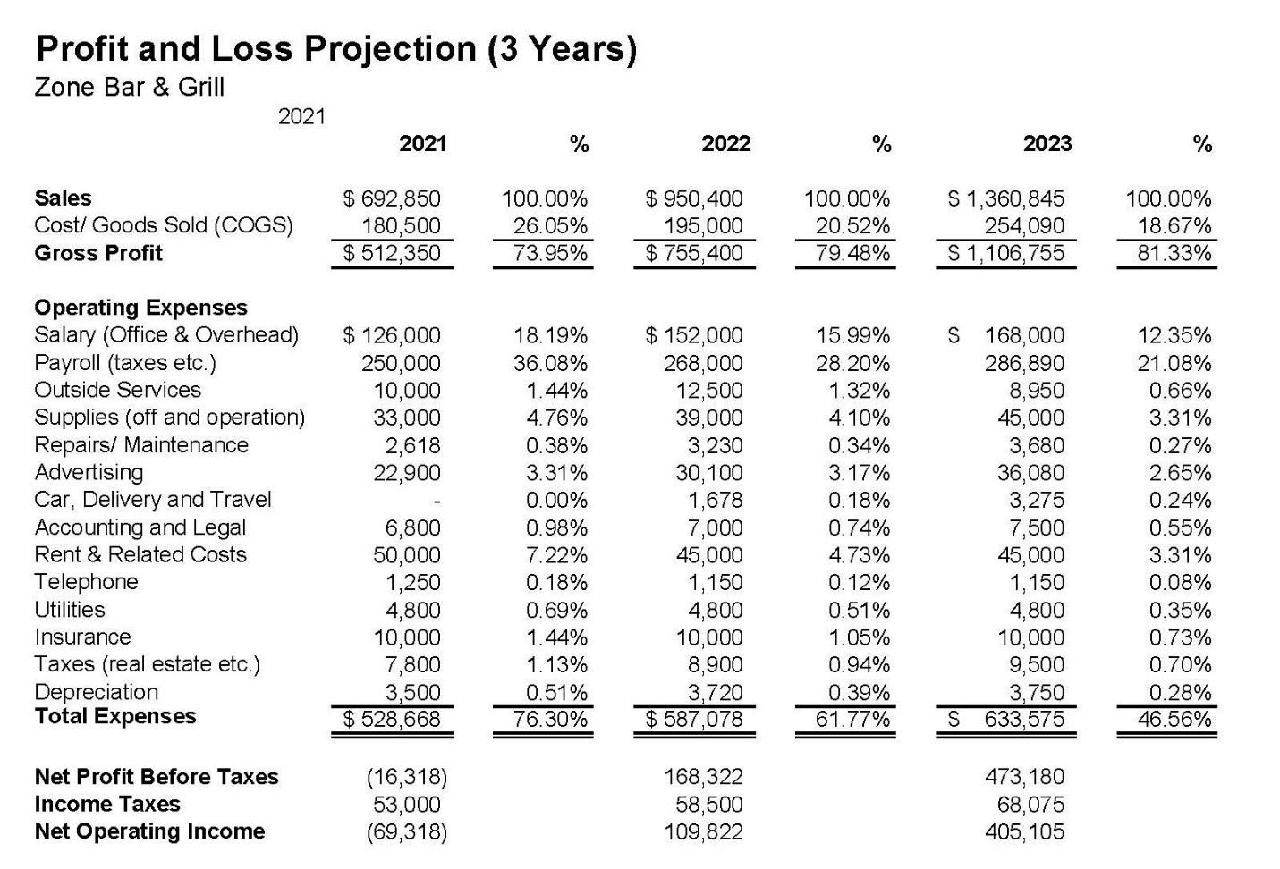
Assumptions
These key assumptions will be showing how the business will be organized and operated within the next three years.
Growth per Year
It is estimated that the business will experience a gradual growth in terms of net profit since it will become popular with time and hence have higher sales.

Consistency Assumption
This assumption is based on the idea that the same method of accounting will be applied from one period of trading to the next. However, it can be replaced by a more relevant method.
Economic Entity Assumption
It is based on the idea that transactions of the business and those of the owner are not combined. If this is not true or ensured then the financial projections will not be true.
Time Period Assumption
The business will be reporting its financial results over uniform and consistent period of time. If this is not ensured, then the financial statements of the business will not be comparable across the three reporting periods (Tyler, Godwin, & Alderman, 2019).
Accrual Assumption
The business will be recording the revenues and expenses as they are incurred basing on accrual basis of accounting.
Reference
Barclay, L., & Glasgow, F. (2008). Small business finance all-in-one for dummies. Chichester: John Wiley.
Tyler, J., Godwin, N. H., & Alderman, C. W. (2019). ACCT3 financial.

